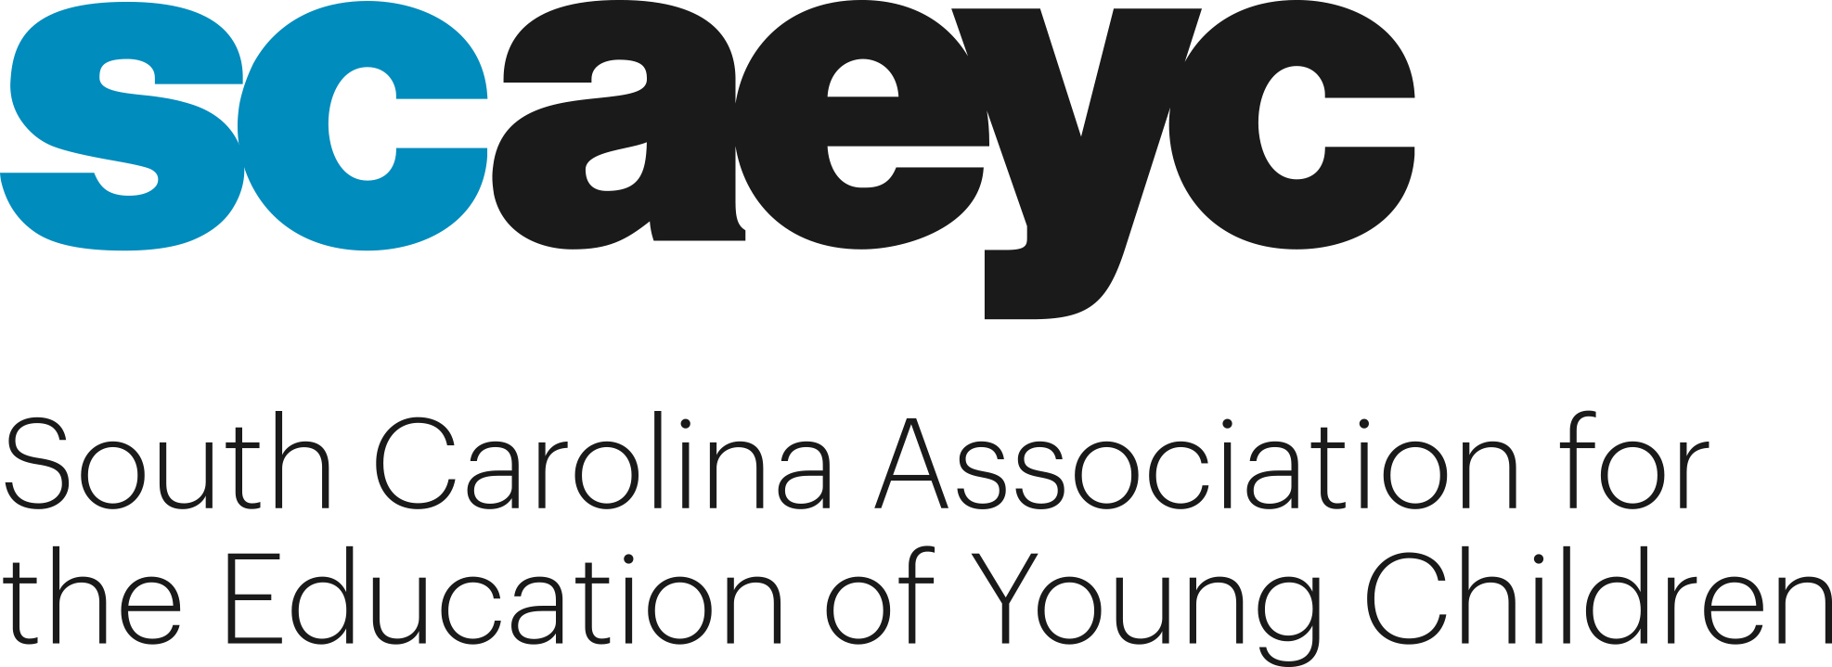

100% Virtual Conference
#thebigIDEA@SCAEYC
(Inclusion, Diversity, Equity and Accessibility)
October 2 - November 13, 2021
Keynote Sessions with Jenna Sekerak - November 12 @ 10
Dr. Iheoma Iruka - November 13 @ 10

REGISTRATION FORM
Name: _____________________________________________________________
Place of Employment or School __________________________________________
SC Endeavors Registry ID#_____________________________________________ Address ______________________City ___________________Zip Code_______________
Phone: E-Mail ___________________________________
Conference Registration Rate – Non-Members $150.00
If you are already a current Standard Member, the fee is $100.00
Conference registration includes a standard membership in SCAEYC/NAEYC. An individual email and mailing address are required.

Your membership includes one print journal. You may choose ___Young Children or ___Teaching Young Children.
Make Checks Payable to SCAEYC Conference and mail to:
SCAEYC P.O. Box 823 Mauldin, SC 29662
To pay with a credit card, e-mail the completed registration form to SouthCarolinaSCAEYC@gmail.com then pay online at http://scaeyc.org/2021-scaeyc-conference-registration-payment/
*Please indicate the email that should be used for the invoice and SC Endeavors ID.

Your conference registration includes any and all sessions from October 2 to November 13, including our two keynote sessions. These sessions will provide an opportunity to learn valuable information and share readings from NAEYC publications.

See the latest session schedule at http://scaeyc.org/2021-scaeyc-conference-schedule/

